Big Mountain Resort

# **Market research**

As we explored our dataset, it was observed that the most important features pertaining to ticket pricing (AdultWeekend) for our modeling efforts were, refer to our correlation plot Fig 7. :

* Vertical_drop (Vertical)
* Snow Making_ac (Snow making area (acres))
* Total_chairs (number of chairs/ski-lifts)
* fastQuads (fastQuad tracks)
* Runs (number of runs)
* LongestRun_mi (longest track)
* Trams (number of trams on site)
* SkiableTerrain_ac (Skiable area)

We compared the Big Mountain to other resorts in the country, and we observed that Big Mountain had priced their ticket price above the market average.

Fig 1. shows where Big Mountain's ticket price is with respect to most of the resorts in the country.

Even in its home state, it is on the higher end of the spectrum as shown in Fig 2.

It might be surprising to see that the ticket price was so high, but when we look at what the price at other parks were for the services that they were receiving, it made more sense.

Let's take a closer look at how the attractions at Big Mountain compare to its competitors.

When we investigated the vertical drops in the country, we can see left skewed curve, suggesting that a majority of the resorts had small drops, however as we can see in Fig 3, Big Mountain has quite a few vertical drops that are on the higher end of curve, in the range of 2000-3000 ft.

Similarly, we've also noticed that Big Mountain was on the higher end of various features such as number of chairs/ski-lifts, skiable terrain that included snow making areas and total number of runs that included fastQuads and longest runs compared to most of the country. Figures 4-9 will show you graphically where these features compare to its competitors.

Based on these features, Big Mountain Resort's modelled price was $95.87, while the actual price is $81.00. Even with the expected mean absolute error of $10.39, this suggests there is room for an increase.

After some discussions with our marketing and BI teams, we decided to try and predict the effect on ticket pricing if we were to increase the number of runs in the park by 1, increase the vertical drops of one of the runs by 150 ft., and include another chair lift.

This scenario increases the support for increasing the ticket price by $8.61, by which we would expect to see a revenue of $15 million over the season.

To add to this, we could further increase our ticket price by $1.29 if we increased the size of a snow making run by 2 acres, by which we could expect an increase in revenue by $2.3 million over the season.

We had also studied how closing the number of runs would affect our pricing model. Fig 8 shows that if we close just one run, it won’t affect our pricing at all. We see a positive correlation between the number of runs closed on the park’s revenue. As we closed runs, we saw a drop in revenue until we closed 3 after which we can see that ticket price and revenue plateaus. This suggests that if we do intend to close 3 runs, we could close 5 without much change in ticket price or revenue. A similar effect is noticed when we close 6 - 8 runs. This opens up avenues for a play on reducing operational charges.

# **Recommendations**

Based on these observations, our team recommends opening a new run, while increasing the vertical drops of the same or another run by 150 ft., adding a chair lift and increasing the acreage of one of the popular snow making runs could potentially see the park’s revenue grow by $17 million over the season.

Note that, while we could potentially see growth in revenue, this prediction did not include the operational expenses that would be incurred for increasing snow making areas or any of the construction expenditure that would go into creating a new run, increasing the vertical drop of a run or adding a new chair lift.

What can also be tried is closing one of the least popular runs as that will not adversely affect your ticket price therefore optimizing park operational expenses.

If Big Mountain does intend to close runs to save on operational costs then, fig 8 should be consulted. There we predicted how closing runs would affect the ticket price and subsequently the revenue of the park. Due to the limited operational expense data provided, it would be difficult to provide an accurate recommendation on what might yield the best results if we’re closing services.

# **Appendix**

Fig 1. Correlation plot depicting how features correlate to each other. Our focus is on the AdultWeekend feature which indicates the ticket price.

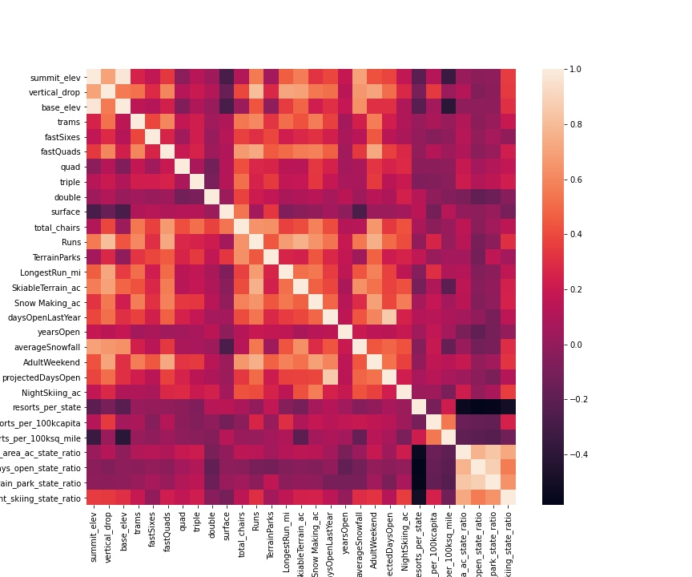

Fig 2. Pricing graph with a left skew indicating that prices are generally on the lower end.

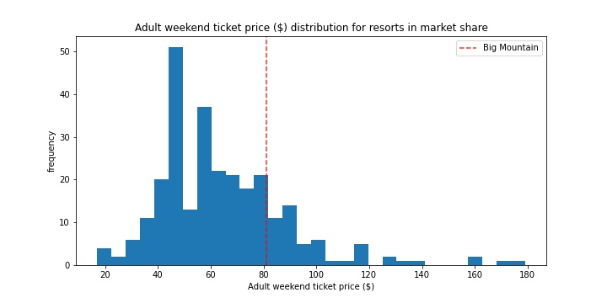

Fig 3. Ticket pricing in Montana. Big Mountain is on the higher end of the spectrum.

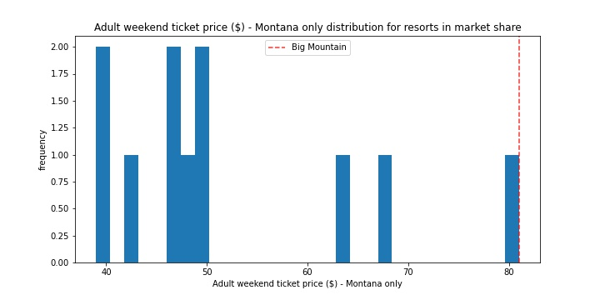

Fig 4. distribution plot showing vertical drop in feet across the country. Left skewed showing that most of the country’s resorts don’t have a very high elevation.

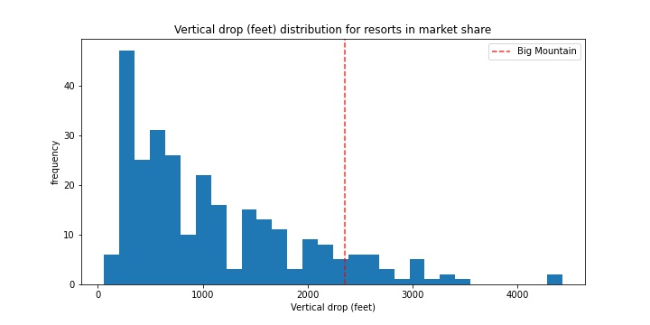

Fig 5. Distribution of resorts based on skiable terrain. Most resorts don’t have skiable terrain.

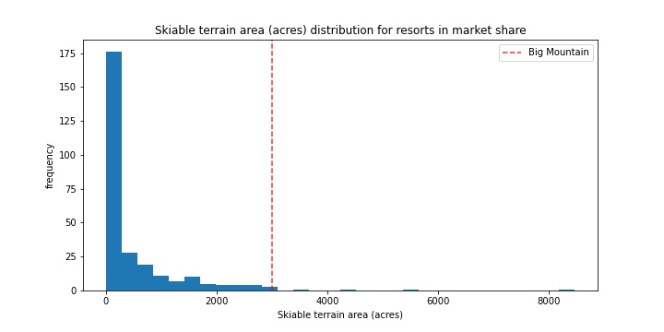

Fig 6. Most resorts cannot accommodate vast areas of artificial snow likely due to geographical restraints.

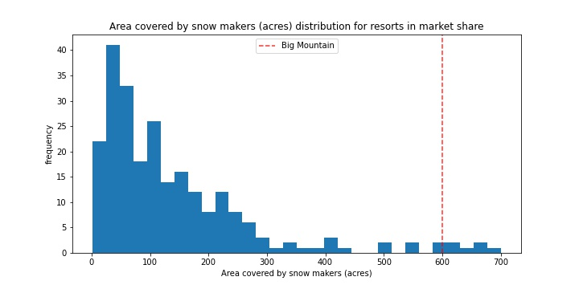

Fig 7. Due to the large size of skiable terrain, Big Mountain can have multiple fastQuads.

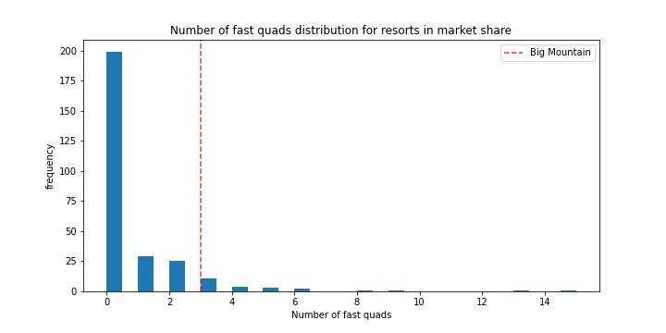

Fig 8.

